

**CG2111A Engineering Principle and Practice**

Semester 2 2022/2023

**“Alex to the Rescue”**

**Report**

**Section 1 Introduction**

“Alex to the Rescue” is a project which uses a tele-operated robot named “Alex” to navigate a maze manually by the operator. The project has following main goals:

1. Use Alex to navigate through an area with a dimension of **189cm * 135cm** ( 7 * 5 maze with each grid of 27cm * 27cm) , and **plot the environment map** manually using the information obtained from Hector SLAM.
2. Identify **one red object** and **one green object**, among the multiple objects in the maze and mark down the two objects’ position in the map plotted.
3. Find a parking slot in the maze with a dimension of **27cm * 27cm** and only one entrance, and park Alex in the slot when 1) and 2) are finished.
4. The above three main goals should be finished within **8 minutes**.

Additional goals:

1. Avoid hitting any walls or obstacles as much as possible.
2. Use shorter time to finish the main goals.

**Section 2 Review of State of the Art**

**Example 1: Packbot.** The packbot was developed to detect improvised explosive devices (IED) and defuse them in bunkers and caves. It has caterpillar tracks to allow it to cross various terrains and has dual BB-2590/U Li-ion rechargeable batteries that allow it to run for 4 to 8 hours with a battery pod that can extend its battery life to 12 hours. It can be controlled via radio or alternatively via a multimode Fibre Optic cable spool mounted on the robot. Has a camera head equipped with multiple cameras, laser pointers, audio and other sensors.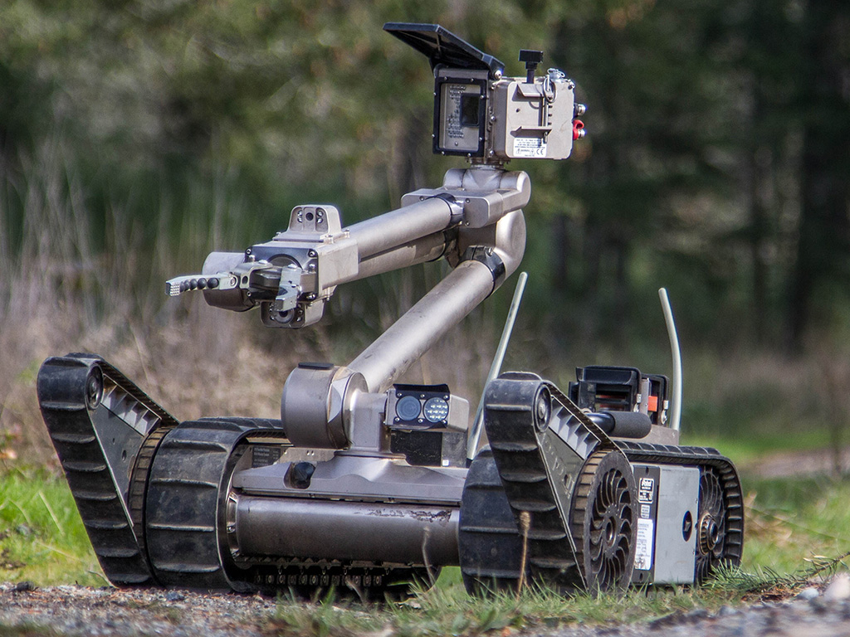

**Strengths:**

1. Versatility: The PackBot is a versatile robot that can be equipped with various sensors and tools to perform a wide range of search and rescue tasks.
2. Mobility: Its caterpillar tracks allow it to cross most rough terrain and climb up to a 60 degree incline and manoeuvre in up to 3 feet of water.
3. Tele-operating capabilities: The PackBot can be tele-operated by an operator who is 1000 metres away.

**Weaknesses:**

1. Limited battery life: The PackBot has a limited battery life, which means it may need to be recharged or have its battery replaced during long search and rescue operations.
2. Limited portability: The PackBot base model weighs 18kg without any add ons. For example, the power pod weighs an additional 6kg.

**Example 2: Foster-Miller TALON.** The Foster-Miller TALON has replaceable lithium ion batteries and is controlled via a two-way radio or fibre-optic link from a portable or wearable Operator Control Unit (OCU) that provides continuous data and video feedback for precise vehicle positioning. It also has many different variants which results in many different possible combinations of components. Sensors, robotic manipulator (for disarming IED), day/night cameras (for reconnaissance), chemical, gas, temperature and radiation sensors (for radiative bombs) and imaging sonar (for water environments).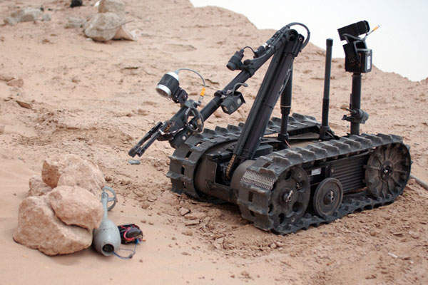

**Strengths:**

1. Tele-operating capabilities: The Talon can be tele-operated by an operator who is 1200 metres away.
2. Rugged and durable: The Talon was able to work for 45 days in a contaminated environment without any electrical faults.
3. Versatility: The Talon is designed to navigate all types of terrain such as sand, water, snow and stairs.

**Weaknesses:**

1. Limited portability: Its lightest version (reconnaissance) is 27kg with its default version weighing 45kg.
2. High cost: The Talon cost 230000 per unit.

**Section 3 System Architecture**

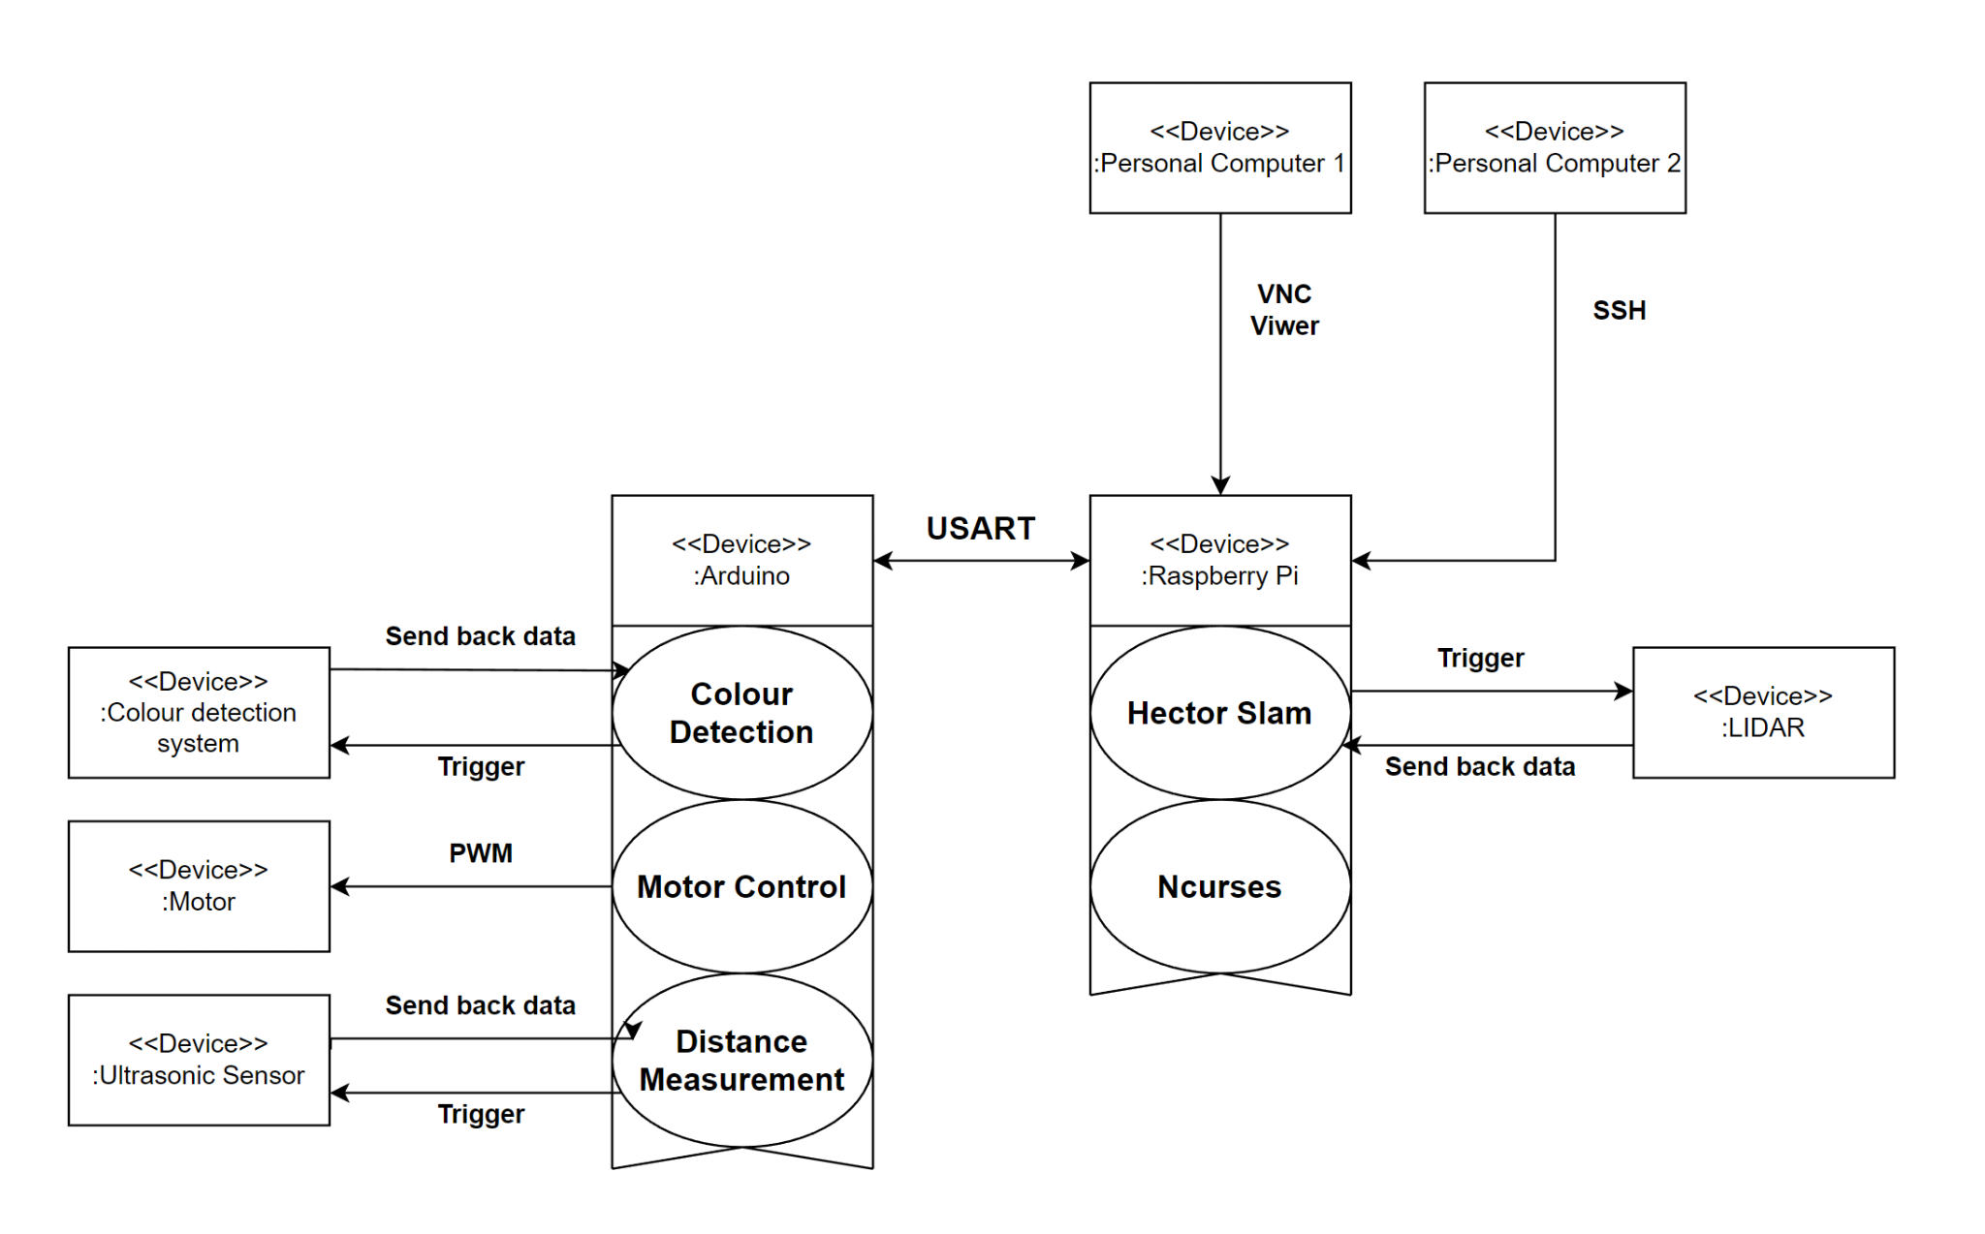

**Section 4 Hardware Design**

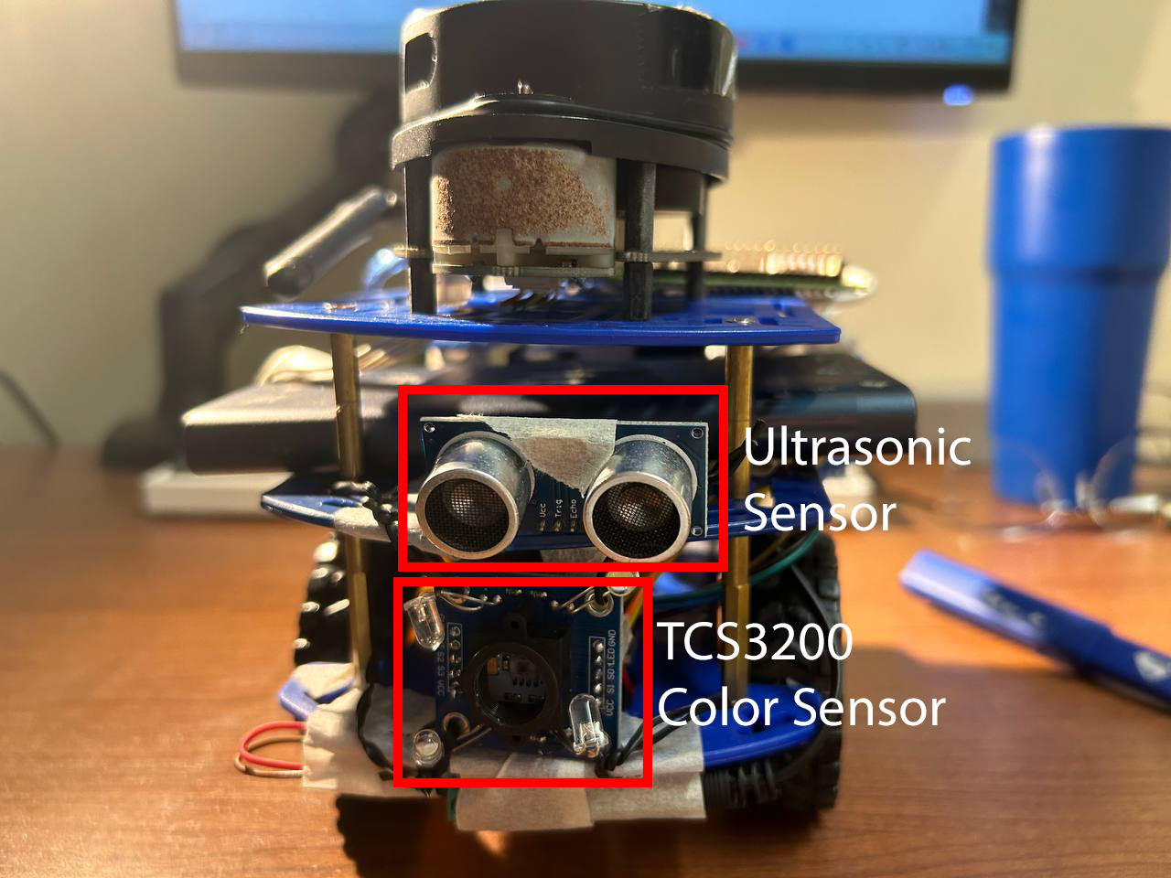

Front View

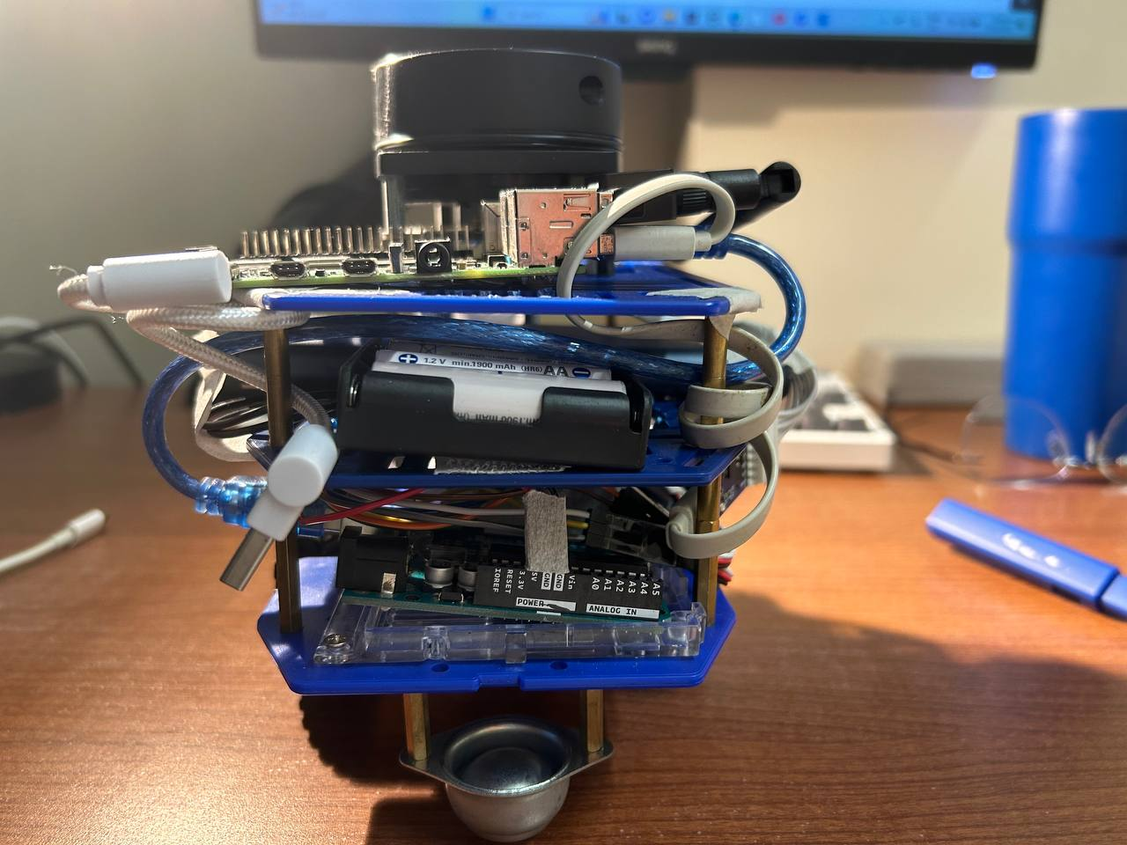

Back View

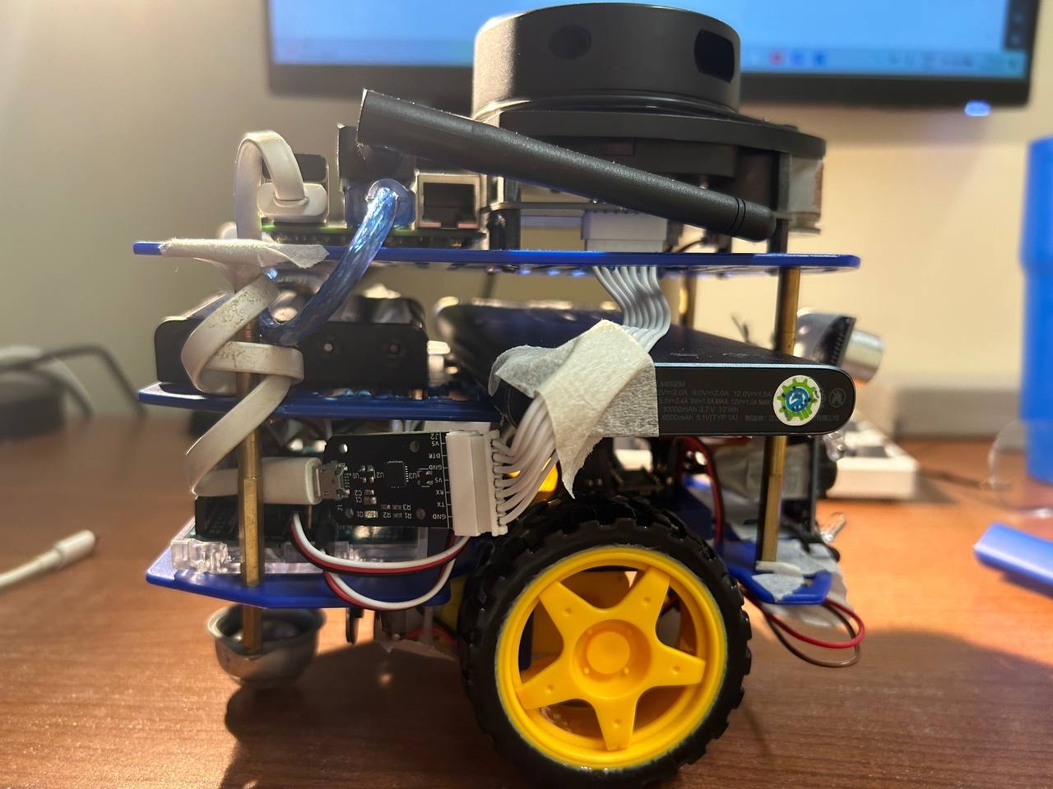

Right View

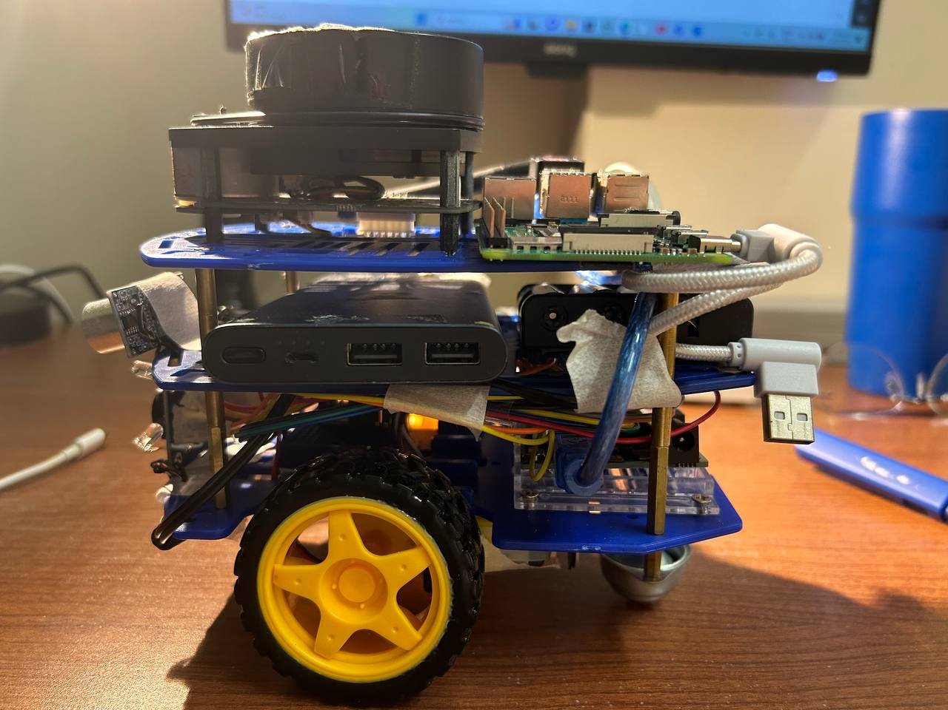

Left View

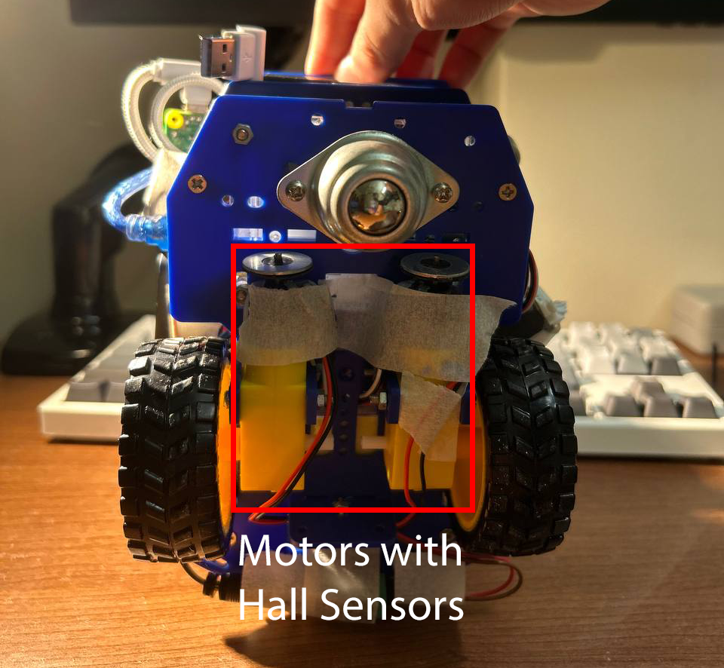

Bottom View

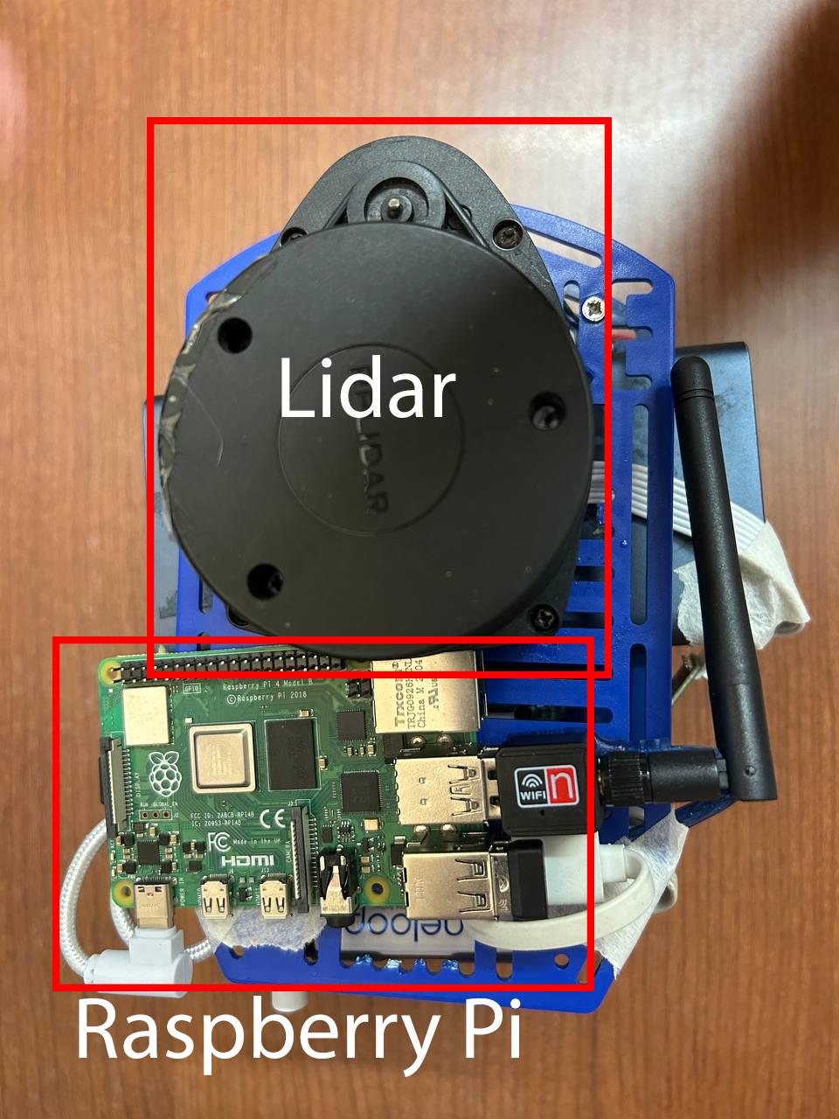

Top View (Top Layer)

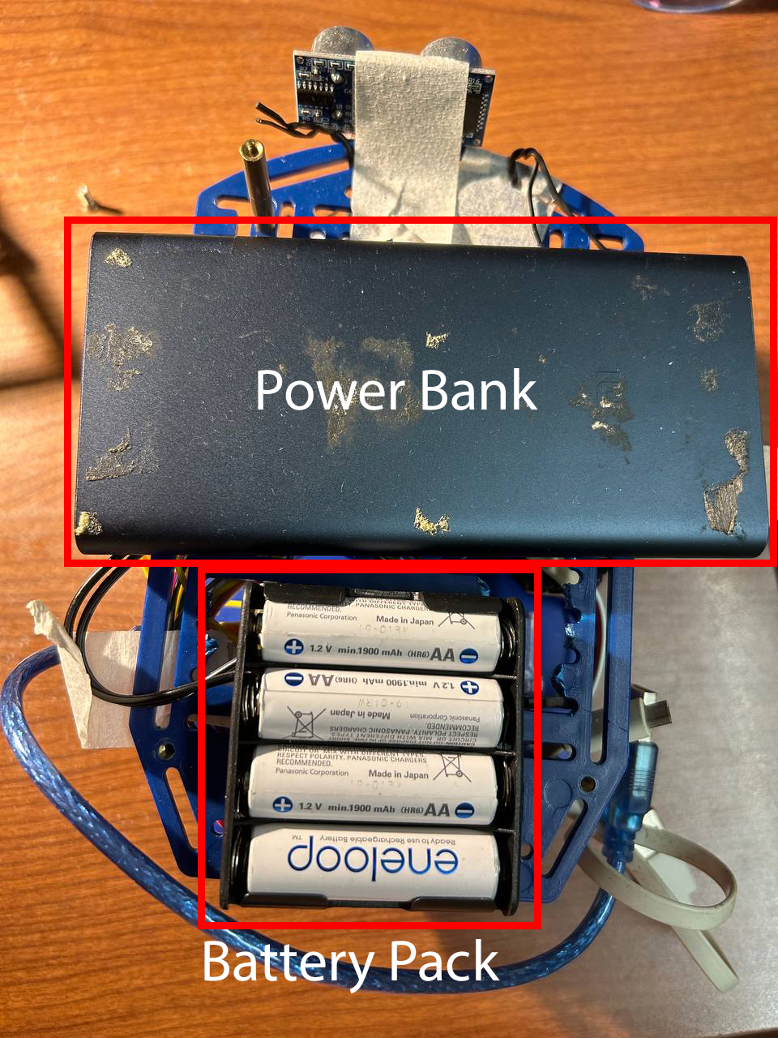

Top View (Middle Layer)

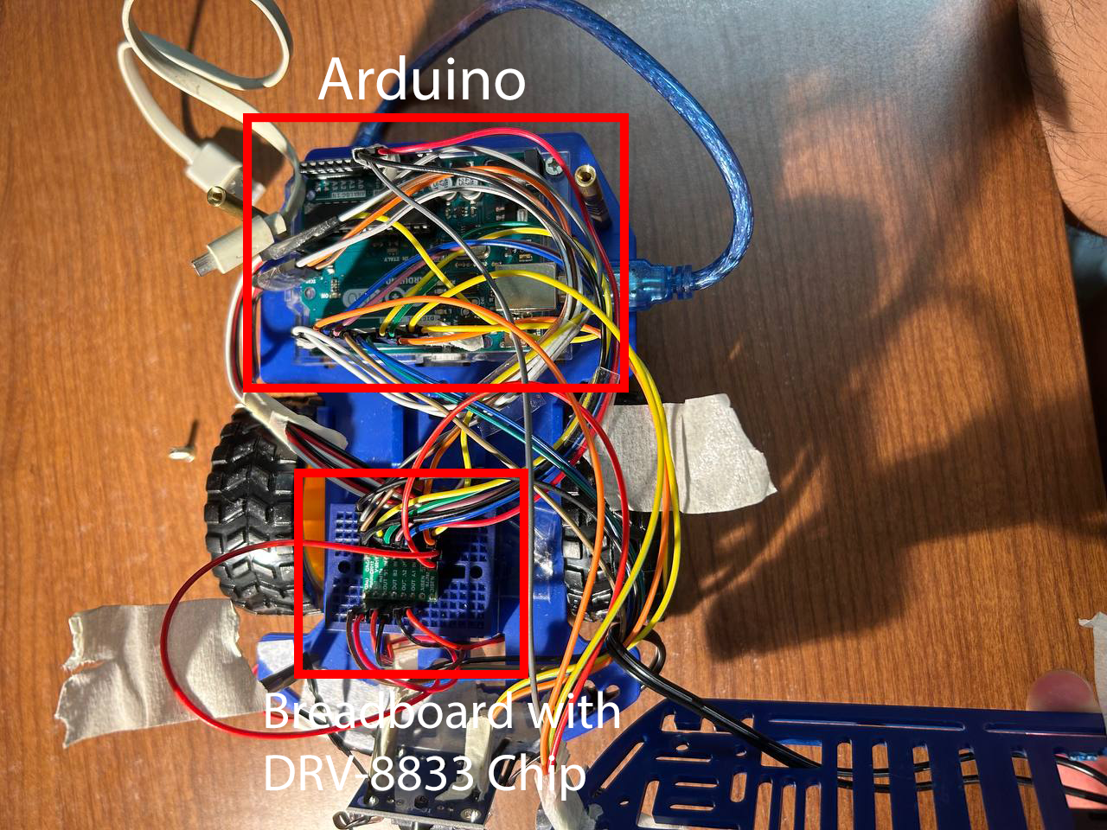

Top View (Bottom Layer)

Non-standard hardware components:

1. Ultrasonic sensor: We include an ultrasonic sensor in the front of Alex (figure *Front View*). The ultrasonic sensor allows us to measure the distance from the wall in front of Alex to Alex itself. It has two purposes. First, since the Lidar we use tends to malfunction when Alex is too close to the wall, the ultrasonic sensor works as an alternate way to measure the distance when we need to park Alex. Second, the ultrasonic sensor also helps to measure the distance between objects and Alex. This allows us to obtain the colour data of the object at a fixed distance making the data obtained from the colour sensor more consistent and easier for us to identify the correct colour.

**Section 5 Firmware Design**

Step 1: Setup

1. Setup the USART
2. Setup the interrupts
3. Setup the pull up registers for the hall sensors
4. Setup the motor pins (set them as an output)
5. Setup the colour sensor
6. Setup the ultrasonic sensor

Step 2: Receive user commands on Arduino

1. Receives the command through the serial communication with a baud rate of 115200.
2. readPacket is called and reads in data from the serial port and deserialises it into “buffer” with size 100 bytes while checking checksum.
3. Arduino sends an OK packet if it receives the instruction or a BAD packet if there was some corruption in the data.

Step 3: Execute received commands

1. Moving: Arduino moves at the specified PWM. The corresponding ticks (left forward, right forward, left reverse, right reverse) are constantly checked in the loop to check the distance travelled. Once the required distance is travelled, the robot stops.
2. Colour Sensor: The colour sensor is triggered by get status and calls the trigger_CD function. The values are stored in the statusPacket.params[11-13] that is sent over to the Raspberry Pi.
3. Ultrasonic Sensor: The ultrasonic sensor is triggered by get status and calls ultra_sensor_dist function. The ultrasonic sensor is triggered and distance measured in front of Alex is sent back to the Raspberry Pi.
4. Get status: The Arduino sends the ticks and distance travelled, colour sensor and distance from the front.
5. Clear status: The Arduino clears the tick counters back to 0.

Step 4: Send response to Raspberry Pi

1. The required data of type TPacket are serialised and stored in “buffer” of size 100 bytes.
2. writeSerial will be called to send the data through the serial communication channel.

Format of message:

One packet of message includes a total 100 bytes of information, which are:

1. packetType (1 byte): packetType is used to state the type of the packet which includes COMMAND, RESPONSE, ERROR, MESSAGE and HELLO. The five different status indicate the purpose of the packet.
2. command (1 byte): This defines what type of command it is by defining which direction to move or stop, get stats or clear stats.
3. dummy[2] (2 byte): Since the raspberry pi will read 4 bytes of data as a packet, a padding of 2 byte of data is needed.
4. data[32] (32 bytes): It is a string for us to write sentences to aid us in debugging.
5. param[16] (16 bytes): param[0] to param[9] are the data we obtain from hall sensors to track the movement of motors and distance travelled; param[10] to indicate the distance obtained from ultrasonic sensor; param[11] to param[13] are the reading from colour sensor which corresponding to R,G,B values of the colour we detected respectively.

**Section 6 Software Design**

1.a. The teleoperation between Raspberry Pi and Arduino is accomplished using USART(Universal Synchronous/Asynchronous Receiver/Transmitter) as well as VNC (Virtual Network Computing) and SSH (Secure Shell Protocol). To establish a USART communication between the two devices, we first connected them using a USB cable. The Raspberry Pi was used to send data to the Arduino, while the Arduino received the data and performed the required operations. The USART communication was established using a common baud rate of 115200, which is a maximum possible baud rate for the serial communication in. Raspberry Pi sends command to the Arduino in robot movement, which will be explained in section 1.c. Arduino also transmits a set of parameters, which includes distance measurement from the ultrasonic sensor and the RGB frequencies from the colour sensor when requested.

To establish SSH communication between the local computer and the Raspberry Pi, we first connected the two devices to the same network. The Raspberry Pi was set up to run a SSH server, and the local computer was used to establish a SSH connection to the Pi using command prompt. Once the SSH connection was established, the user was able to remotely execute commands on the Raspberry Pi and control the robot.

We used VNC to connect our personal computer to the Raspberry Pi, which allowed us to view and manipulate the files in Raspberry Pi. It was mainly used to view the Hector Slam output.

1.b. The colour detection algorithm works as such. First, the light from the LEDs on the colour sensor reaches the object. Depending on the colour of the object, a certain percentage of red/blue/green light is absorbed and the rest is reflected. A receiver on the colour sensor then reads the frequencies of the reflected light, which helps in determining the RGB (Red, Blue, Green) value of the object. We included the RGB values as part of statusPacket of type TPacket. The RGB values are returned in the array params from index 11 to 13. The RGB values can be obtained from the "Get-Status" when we run ./alex-pi. Based on the measured values and the identified relationship between the frequencies of the three colours, we can determine the colours of the victim based on the trend that we identified in the preliminary measurements.

1.c. The ncurses was used in Alex’s controlled movement using arrow keys. To implement this functionality, we first installed ncurses on the Raspberry Pi. To enable the use of arrow keys to control the Arduino, the ncurses library was used to capture the user input and map it to the appropriate command for the Arduino. This was accomplished by using the getch() function provided by the ncurses library, which captures user input from the keyboard without the user having to type Enter. This makes controlling the robot more efficient and convenient. The code below was added to the original alex-pi.cpp and saved as alex-pi-ncurses.cpp.

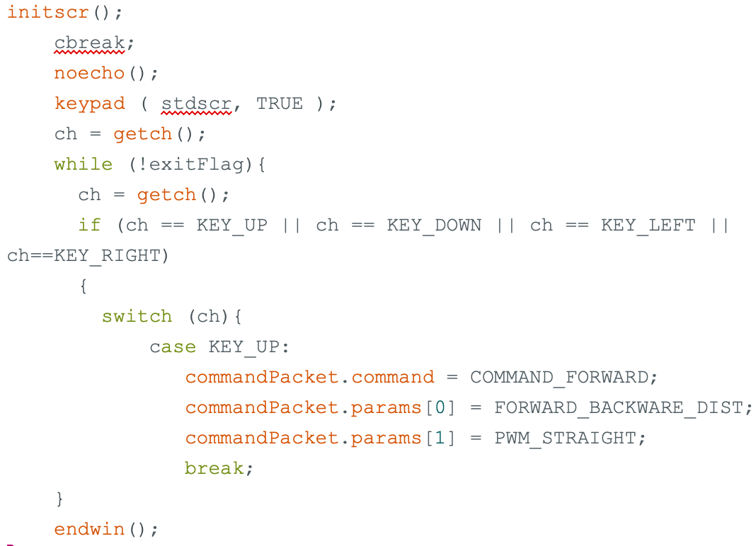

**Section 7 Lessons Learnt - Conclusion**

**Lessons Learned**

Lesson 1: We learnt the importance of securing the wiring of the robot with tape. A lot of the jumper cables were compacted together on the first level of the robot. This led to the jumper cables to bulge out of the frame of the robot and get easily caught onto walls when moving. Moreover, upon colliding with a wall or even by carrying the robot from place to place some cables came loose which led to unnecessary debugging. Another issue that arose from moving the robot or the robot bumping into walls was that either the hall sensor came loose or it went too close to the magnet. This led to the issue of the robot not stopping and not moving respectively.

Lesson 2: We learnt not to tunnel vision and in the end found a better way of determining colours based on the readings given by the colour sensor. Our initial approach to detecting the colour of the victims (the red and green objects) was inspired by what we did in EPP1, to observe the trend of the red, green and blue values and write a function that would give the colour. However, this led to our robot to misidentify colours frequently as some of the values were close and as the robot traversed around the maze, the lighting condition would often change resulting in fluctuating red, green and blue values. It was only after a while did we realise that there was no need to write a function to determine the colour. Instead it was much better to use human judgement by directly looking at the values provided by the colour sensor to determine the colour of the object.

**Greatest Mistakes**

Mistake 1: Our stubbornness in changing our initial design of Alex. Our initial design while functional was plagued with problems. The lidar was pointed 90 degrees to the right, the wires connecting the Arduino to the Raspberry Pi and the Raspberry Pi to the Lidar were not compact. The former resulted in us having to constantly reorient ourselves when piloting Alex and the latter resulted in Alex being larger than necessary and getting caught in walls, especially when performing tight turns. The last straw that broke the camel’s back was the power bank, which was taped to the underside of the second layer and kept falling off when Alex moved. This led us to rethink our initial approach and we eventually redesigned it to have 3 layers instead of 2 and to reposition some of the components to make space for the lidar to face the front and for the wires to be either taped or coiled to make the form factor of Alex smaller.

Mistake 2: Poor planning of the usage of arduino ports and wiring of the breadboard. We initially wired up the breadboard for whichever functions we needed first, namely the motors and the hall effect sensors. This led to there being little space on the breadboard and a lot of unnecessary criss cross of wires. This resulted in us having to rewire some of the connections by creating common 5v lines and ground lines to save space and by selecting ports that were physically near each other for wires that go to the same component. This mistake also resulted in us having a harder time to debug as it was harder to trace the wire.

**References**

<https://www.flir.asia/products/packbot/>

https://en.wikipedia.org/wiki/PackBot

https://en.wikipedia.org/wiki/Foster-Miller_TALON